SHULL SCIENCE · JAMES A. GARFIELD LOCAL SCHOOLS
UNIT 2 TEST: WRITTEN
UNIT 2 TEST · DAY 2 · WRITTEN
NAME | DATE | PERIOD | SCORE / 14

You may use a periodic table. Write every configuration in order of filling. In the orbital diagram, each electron gets one arrow.

Part 1 Longhand configurations | 8 points

Number 1 also needs its orbital diagram.
1 | 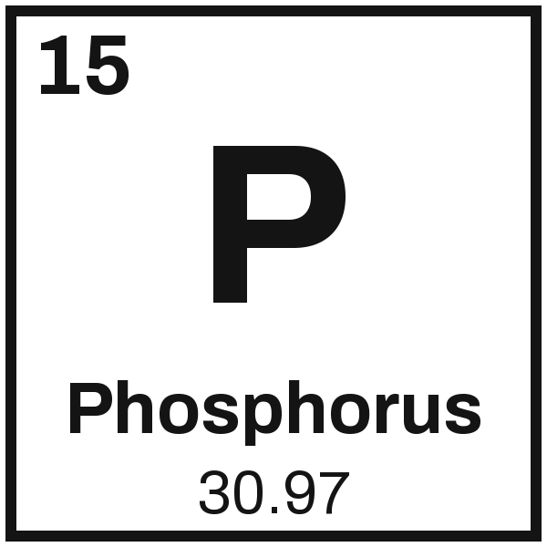 | Configuration
1 |  | Orbital diagram

2 | 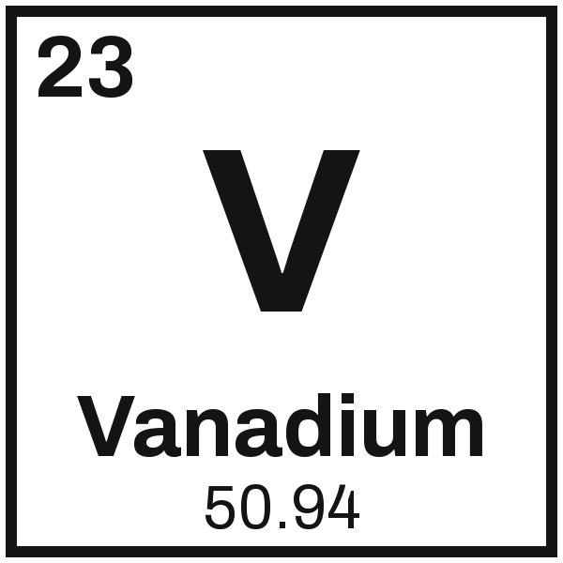 | Configuration

3 | 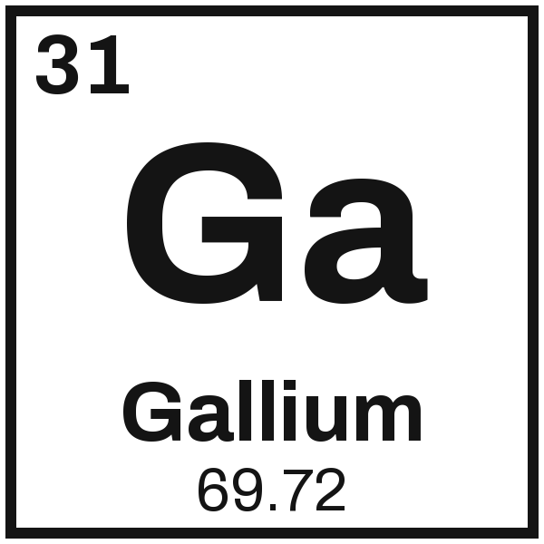 | Configuration

Part 2 Noble-gas shorthand | 6 points

4  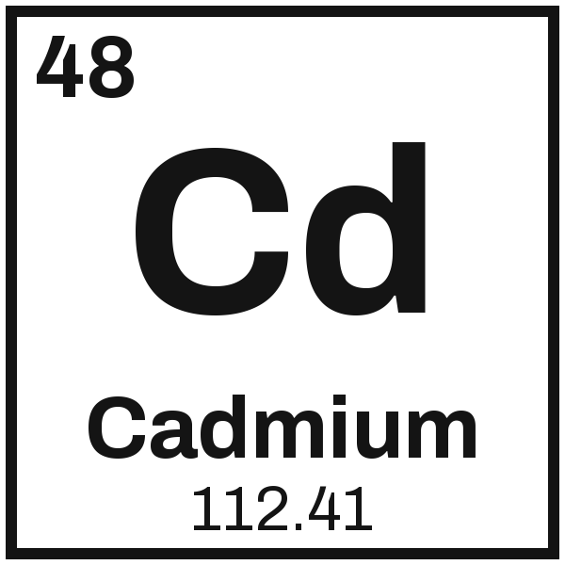 | 5  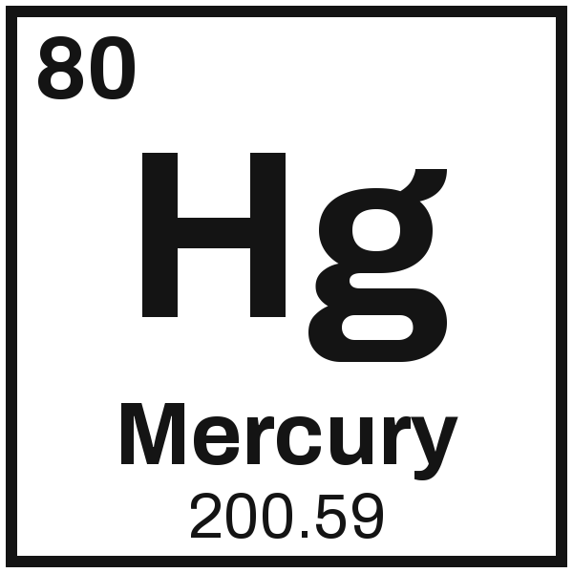 | 6  